 *Myntra*

**Product Dissection for Myntra**

### **Company Overview:**

Myntra is India’s most significant e-commerce company committed to making fashion and life products available to everyone. Myntra aims at delivering a hassle-free and pleasurable shopping experience to shoppers across the country with the broad range of brands and products on its portal. They produce results that disrupt the ordinary and help make the world a happier, more stylish place. From its onset as a customization company in 2007 to being Myntra has evolved to be the technology and fashion settlers' moment.

### 

### **Product Dissection and Real-World Problems Solved by Myntra:**

With its innovative product line, Myntra, a leading e-commerce platform, has successfully tackled practical issues. Myntra has revolutionised online shopping in India by focusing on affordability, convenience, and customer satisfaction. Myntra offers practical answers to its customers' changing needs through a wide selection of products, safe payment methods, and dependable delivery services.

Myntra has completely changed online shopping in India with its user-friendly interface and tailored shopping experience. Myntra addresses users' hesitancy and uncertainty when it comes to online shopping by offering comprehensive product descriptions, customer reviews, and product recommendations. Furthermore, consumers are reassured by Myntra simple return and refund procedures, which promote platform loyalty and trust.

In summary, Myntra has effectively addressed practical issues through the development of a platform that places a premium on user convenience, price, and confidence. Myntra has revolutionized the e-commerce landscape in India by providing a wide range of products, a user-friendly platform, and trustworthy services that make online buying more convenient and pleasurable for millions of customers.

**Case Study: Real-World Problems and Myntra's Innovative Solutions**

**Problem 1: Limited Accessibility**

**Real-World Challenge:**

Traditional shopping took physically visiting physical stores, which forced people's approach to a limited number of brands and products. Physical stores had limited space to display products, performing in a defined range of fashion choices. Customers had to count on native stores and were held down to the available options in their territory.

**Myntra's Solution:**

Myntra solves this issue by extending a vast online list that includes a broad range of fashion products from colourful brands, offer customer access to an expansive collection of outfit, footwear, accessories, and more

**Problem 2: Time Constraints**

**Real-World Challenge:**

Shopping in physical stores usually demands a considerable amount of time. Customers had to proceed to multiple shops, traverse through crowded stores, and stay by long ranges during peak hours. This was particularly difficult for busy individualities who try hard to find time for shopping.

**Myntra's Solution:**

Myntra solves this problem by getting the shopping experience online, where customer can browse and purchase products accessible from anywhere, anytime and removes the constraints of traditional store hours. This ensures that customers can shop at their convenience, without having to visit physical stores during specific opening hours which saving valuable time and struggle

#### 

#### **Problem 3: Secure and Convenient Online Transactions:**

**Real-World Challenge:**

Customers may be concerned about the security of their payment details and the potential for online fraud.

**Myntra's Solution:**

Myntra ensures secure online transactions by employing encryption and secure payment gateways, providing customers with a safe environment to make purchases and also supports various secure payment options, including credit/debit cards, net banking, mobile wallets, and cash on delivery. Additionally, Myntra educates customers about best practices for safe online transactions, building trust and confidence.

**Problem 4: Inconvenient Returns and Exchanges**

**Real-World Challenge:**

Returning or changing fashion products bought from physical stores could be an inconvenient process. It frequently involves visiting the store again, staying in ranges, dealing with store processes, and handling paperwork, it causes dissatisfaction and frustration.

**Myntra’s Solution:**

Myntra provides a user-friendly returns and exchange procedure, enabling users to return or exchange easily in case a product doesn't meet their requirements. This result saves users from the problem of actually visiting stores and going through lengthy return processes.

**Problem 5: Price Comparisons**

**Real-World Challenge:**

Comparing prices across various stores user to needed visits each store and manually comparing cost of items. Customers had to spend time and effort into choosing the correct deals, which could be tedious and time-consuming

**Myntra's Solution:**

Myntra allows users to easily compare products in terms of cost, style, features, and reviews. This simplifies the decision-making process, as customers can quickly estimate different options without actually going to multiple stores.

**Top Features of Myntra :**

**Easy and Intuitive User Experience:** Myntra provides a user-operated interface and navigation, assuring a flawless shopping experience. users can filter the results by size, colour, brand, and price range, making it simple to find required products. All detailed descriptions, images, and customer reviews available of products helps user in their purchase opinions

**Order summary:** Numerous E-Commerce stores allow users with a summary before taking them to the payment screen. By giving users an order summary they can verify before payment, it reduces the threat of returns or order issues that take time and money to solve, affecting the user experience.

**Detailed product descriptions:** By providing extensive product information, you can reduce the risk of product return and client dissatisfaction. Customers can check the product’s details such as type, size, colour, material, and warranty to purchase the right one

### **Secure Payment Options:** Myntra supports multiple payment options, including credit/debit cards, net banking, mobile wallets, and cash on delivery. users can have all these multiple choices and select their preference mode as per they want.

### 

### **Style Inspiration and Content:** Myntra offers style innovation through classified collections, latest reports, and fashion articles. Users can explore collection, fashion tips, and celebrity styles which helping them stay streamlined with the newest fashion trends and take valid buying opinion

### 

### **Myntra Insider Loyalty Program:** Myntra offers a fidelity program called Myntra Insider, providing rewards, benefits, and access to exclusive deals, events, and early access to limited edition products for loyal customers. This program enhances the overall shopping experience and encourages customer fidelity.

### 

### 

### 

### 

### 

### **Schema Description:**

The schema for Myntra involves multiple tables like customer, product, category, order, payment, shipment. Each table have different attributes that describe its properties and relationship with other tables

**Product:** The set of products available for purchase on the platform.

● **product_id (Primary Key):**  A unique id for each product

● **SKU:** It’s a store or catalogue product and service identification code

● **description:** Description about the product

● **price:** Product price

● **stock:** stock of the product Available

**Customer:** This entity represents the customers who create an account to place orders on the online shopping platform.

● **customer_id (Primary Key)**: A unique identifier for each user.

● **first_name**: User’s first name

● **last_name:** User’s last name

● **email**: The user's email address for account-related communication.

● **password:** A encrypted password for user authentication

● **address:** User’s address

● **phone_number**: The user’s contact number.

**Category:** Categories in which the products are grouped

● **category_id (Primary Key):** A unique identifier for each category

● **name:** Name of the category

**Order:** Product orders placed by customers

● **order_id:** A unique identifier for each order

● **order_date:** Date of order placed by user

● **total_price:** Total price of placed order

● **Customer_customer_id (Foreign key referencing customer entity):** User who order the product

● **Payment_payment_id (Foreign key referencing payment entity):** Payment of order done by user

● **Shipment_shipment_id (Foreign key referencing shipment entity):** Reference to shipment of order

**Order_Items:** Each item that is part of an order.

● **Order_item_id:** A unique identifier for each order

● **Quantity:** Total quantity of products order by user

● **Price:** The price of product at time of order

● **Product_product_id (Foreign key referencing Product entity):** product which order by user

● **Order_order_id (Foreign key referencing order entity):** Reference to the Order of customer

**Payment:** The payment made by the customer once the order is completed.

● **payment_id:** A unique identifier for each payment

● **payment_date:** date of payment done by user

● **payment_method:** The payment mode of order

● **payment_amount:** Total amount paid by user

● **Customer_customer_id (Foreign key referencing Customer entity):** who done the payment

**Shipment:** Shipping information associated with an order, including delivery address and tracking information.

● **shipment_id:** A unique identifier for each shipment

● **shipment_date:** Date when items leaves warehouse and it’s way to customer

● **address:** customers address where order should be deliver

● **city:** City of address

● **state:** State of the address

● **country:** Country name where order deliver

● **zip_code:** Postal code of address

● **Customer_customer_id (Foreign key referencing Customer entity):** Reference to the Customer for delivery of order

**Cart:** The customer’s virtual basket or shopping cart, which stores items before they are purchased and become part of an order.

● **cart_id:** A unique identifier for each item cart

● **quantity:** quantity of item added into cart

● **Customer_customer_id (Foreign key referencing Customer entity):** Reference to the Customer added to cart

● **Product_product_id (Foreign key referencing Product entity):** Reference to the Product added to cart

**Wishlist:** Stores items chosen by the customer for possible future purchases.

● **wishlist_id:** A unique identifier for each Wishlist

● **Customer_customer_id (Foreign key referencing Customer entity):** Reference to the customer added to Wishlist

● **Product_product_id (Foreign key referencing Product entity):** Reference to the Product added to the Wishlist

**Relationships are:**

**Customer – Order :** A Customer can have multiple Orders, having a one-to-many relationship. Each Order is associated with a single customer.

**Order – Order_Item:** An order consists of multiple items, creating a one-to-many relationship. Each order item is part of a single order, but an order can have multiple order items.

**Product – Order_Item:** Each order item corresponds to a particular product, creating a many-to-one relationship. Multiple order items can refer to the same product.

**Customer – Payment:** A user can make multiple payments, establishing a one-to-many relationship. Each payment is associated with a single user (one user can make multiple payments).

**Order – Payment:** An order can have one or more associated payments, creating a one-to-many relationship. A single order can have multiple payment transactions associated with it.

**Product – Category:** Products are categorized into various categories. This represents a many-to-one relationship, where multiple products can belong to the same category, but each product belongs to only one category.

**Customer – Cart:** customer can have a shopping cart, establishing a one-to-one or one-to-many relationship, depending on the business rules. Each user might have a single active cart at a time, but it's also common to allow customers to have multiple active cart.

**Cart – Product:** A shopping cart can contain many products, and a product can be part of multiple shopping carts (for example, in the case of shared carts for collaborative shopping). This represents a many-to-many relationship and is typically implemented through an intermediary table

**Customer – Wishlist:** A customer can have a Wishlist, creating a one-to-one or one-to-many relationship. A customer can have multiple Wishlist, or a single Wishlist might fulfil the customer’s needs.

**Wishlist – Product** The relationship between Wishlist and product is also a many-to-many relationship. A product can be part of multiple Wishlist and a Wishlist can contain multiple products.

**ER Diagram:**

An ER diagram that vividly portrays the relationships and attributes of the entities within the Myntra schema. This ER diagram will serve as a visual representation, shedding light on the pivotal components of Myntra data model. By employing this diagram, you'll gain a clearer grasp of the intricate interactions and connections that define the platform's dynamics.

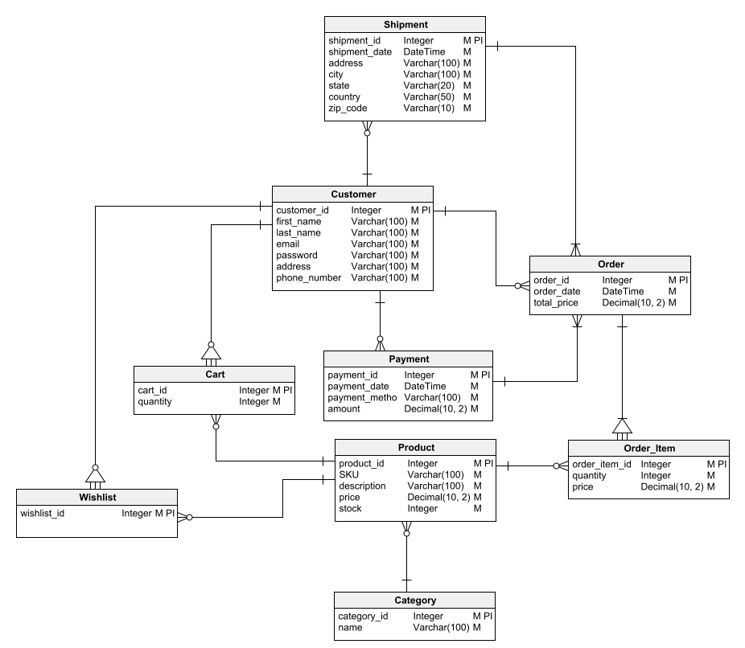

**Conclusion:**

In conclusion, the dissection of Myntra's product attributes and schema design, highlights the company's superior ability to solve real-world issues. The smooth interactions between consumers, orders, products, payments, and more are coordinated by Myntra’s schema. Myntra makes efficient order processing, inventory management, and user engagement possible by carefully designing entities and their relationships. The schema shows Myntra’s dedication to offering a dynamic and customer-focused e-commerce platform. Fully analyzing Myntra’s schema allows us to see how the platform handles product listings, transactions, and user interactions—all of which contribute to its success in the competitive e-commerce market.